**FINDMART DOCUMENTATION**

**Integration of SMS API (Fast2SMS):**

Open your find mart application file and move over to (‘application -> helpers -> sms_helper.php’)

You will see this function

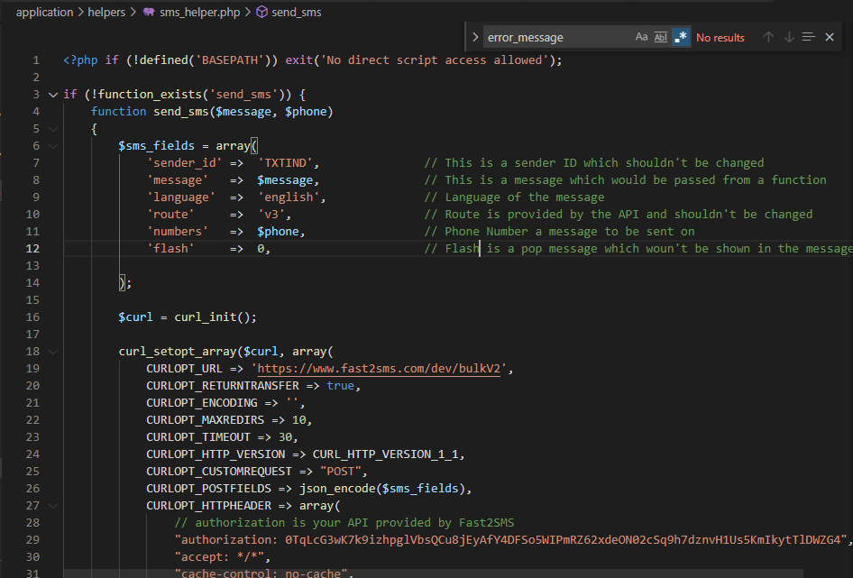

1. **Sender ID:** Provided by FAST 2 SMS and do not change it please
2. **Message:** Message is provided when a function is called
3. **Language:** Language of the message
4. **Route:** ‘V3’ Provided by FAST 2 SMS
5. **‘numbers’:** phone number a message to be sent on
6. **Flash:** POP message or a standard message.

**To Change the Limit of Login Attempts**

* In order to change the login attempts, head over to (‘application -> controllers -> Home.php’)
* Search for $this->session->userdata(‘attempt’) > 7 => (where 7 is an attempt limit)

Login limit which is 7

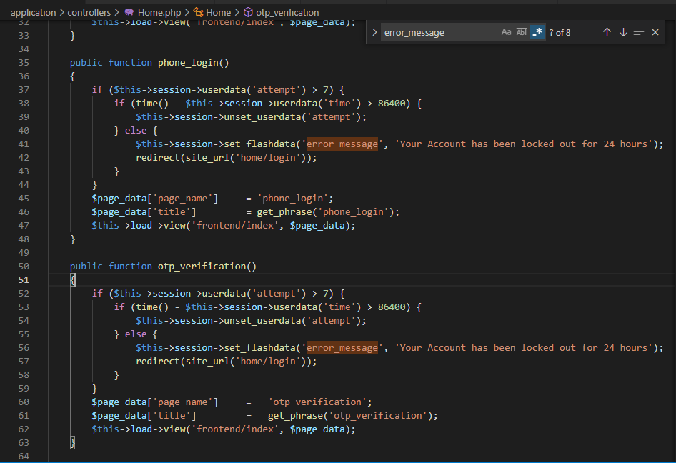

Lock Account for specific time in seconds.